Matt McDade

Algorithms Project 3 Examples

pgm format – original image, correct/provided image, image that my program produced

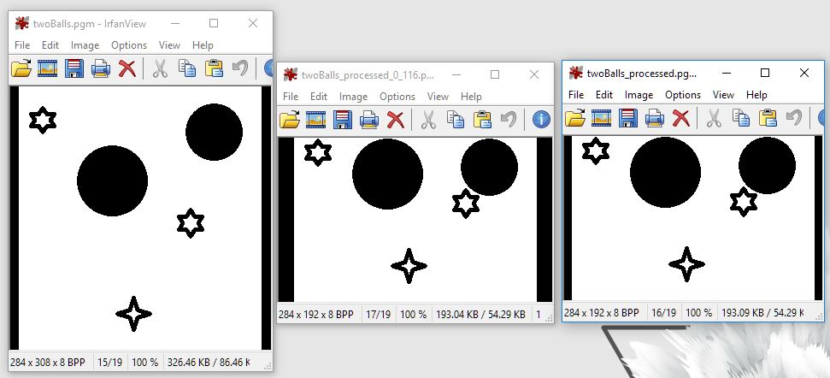

a.exe twoBalls.pgm 0, 116

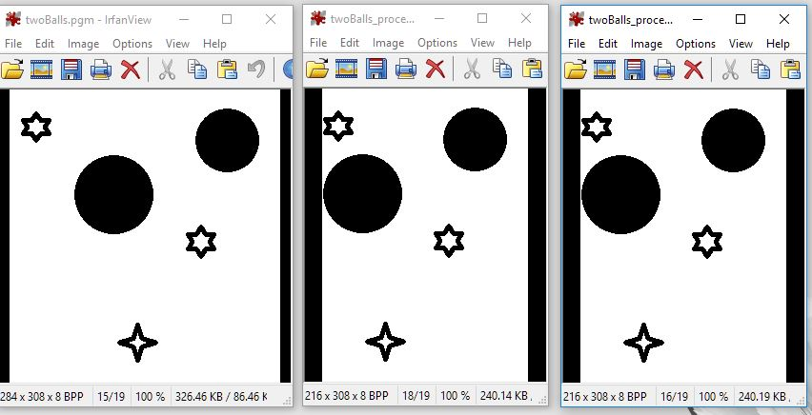

a.exe twoBalls.pgm 68 0

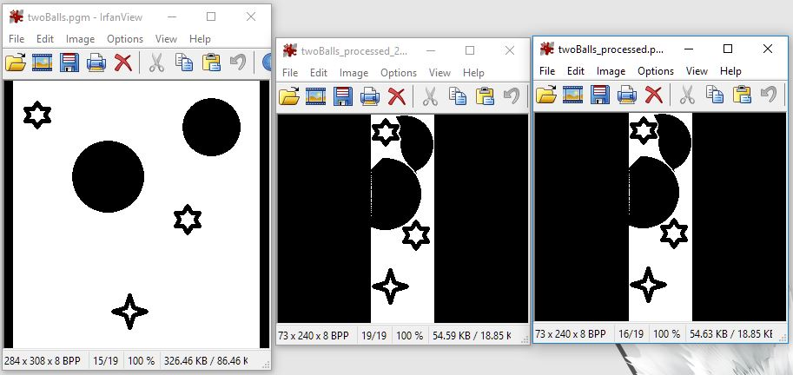

a.exe twoBalls.pgm 211 68

ppm format – original image, image that my program produced

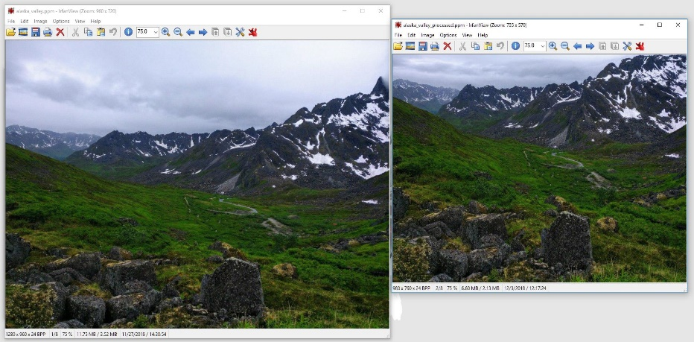

a.exe alaska_valley.ppm 200 200

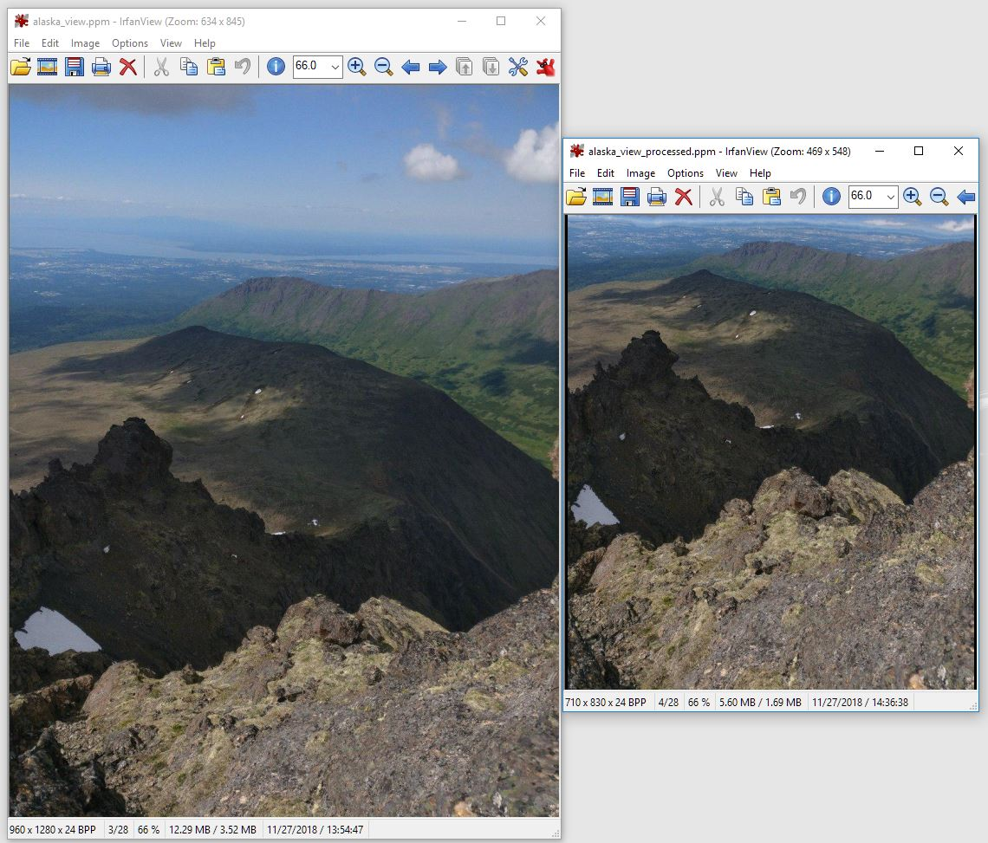

a.exe alaska_view.ppm 250 450

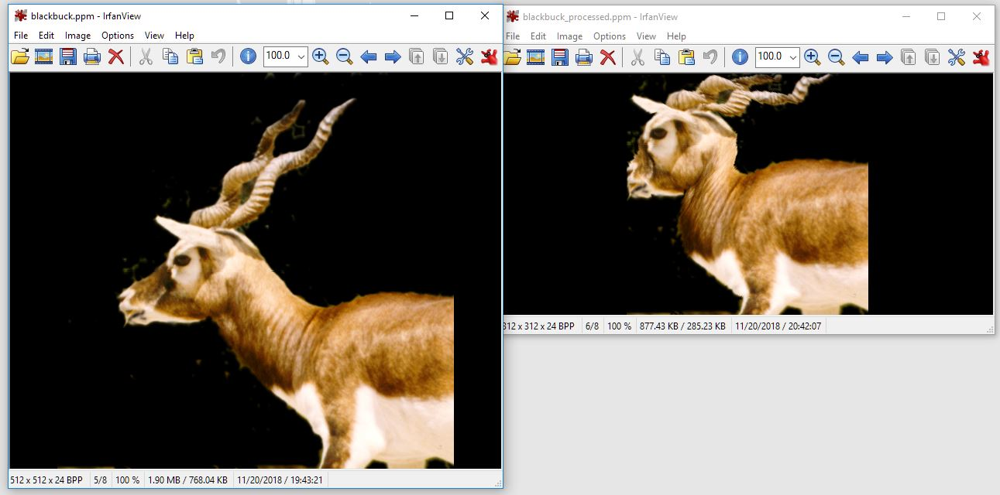

a.exe blackbuck.ppm 200 200